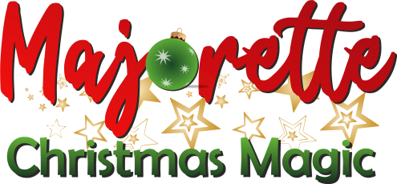
INTERNATIONAL MAJORETTE CHAMPIONSHIP
MAJORETTE CHRISTMAS MAGIC
VITERBO-IT/16.12.2023.
APPLICATION FORM
FOOD
DEADLINE-05.12.2023.
DATE: | LUNCH/09.00 eur | LUNCH/09.00 eur
16.12.2023. | Monoporzione di lasagna al ragnu Bolognese  Nugget di pollo e insalate fantasia  Crostatina al cioccolato  Bottiglietta acqua naturale | Single portion of lasagna with ragnu Bolognese  Chicken nuggets and fancy salads  Chocolate tart  Natural water bottle

E-MAIL: roma.christmas.magic@gmail.com
TEAM:
CONTACT PERSON:
E-mail:
Mob:
Data for invoice:

16.12.2023. | LUNCH/09.00 EUR | ALL:
ALL:

Date:_____________________ Signature:______________

